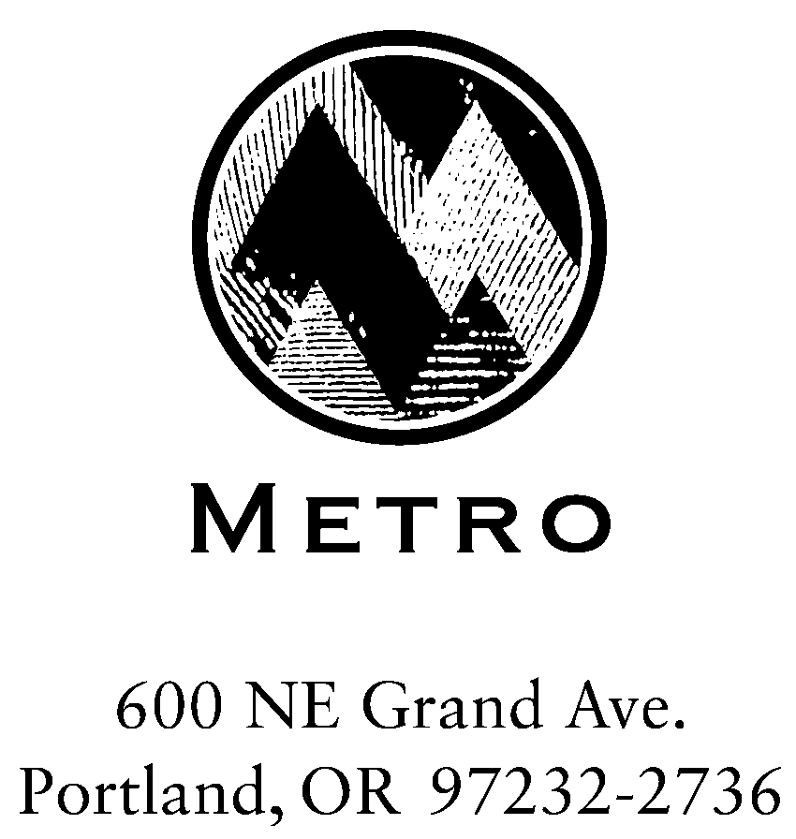

MEETING SUMMARY

SWAC Subcommittee - RSWMP Sustainability Group

Metro Regional Center, Room 275
July 19, 2005

Members Present:
Eric Merrill, Waste Connections
Steve Apotheker, Metro, SW&R, Waste Reduction & Outreach Division
Jeff Murray, Far West Fibers
Lori Stole, Washington County Citizen
Wade Lange, Ashforth Pacific
Dave White, Oregon Refuse Recycling Association

Guests and Metro staff:
Janet Matthews, SW&R
Melissa Bergstrom, Metro, SW&R, Administrative Secretary

Members Absent:
Babe O’Sullivan, City of Portland
Mike Miller, Gresham Sanitary
Tom Badrick, Legacy Health Systems

The Sustainability subcommittee decided that the definition that would be used for sustainability would be taken from ORS184.421, in which “sustainability” means “…using, developing and protecting resources in a manner that enables people to meet current needs and provides that future generations can also meet future needs, from the joint perspective of environmental, economic and community objectives.” The group also agreed to reformulate the definition that they had created in earlier meetings to use as a decision-making framework for implementation.

The subcommittee’s framework definition is as follows: “Achieving sustainability requires considering the economic, environmental and societal resources of the solid waste system consistent with the Natural Step framework and system conditions; i.e., in a sustainable society nature is not subject to systematically increasing:
- Concentrations or substances from the Earth’s crust,
- Concentrations of substances produced by society, or
- Degradation by physical means; and
- In that society human needs are met worldwide.”

Ms. Janet Matthews, Metro, reminded the group that when the final goal and objectives are presented to SWAC and the Metro Council that it would be important to have examples to give people a better idea of what is trying to be accomplished with the chosen goals and objectives. The following are the goals and objectives that the group agreed upon in this meeting:
Goal 1: Reduce greenhouse gas and diesel particulate air emissions.
- Objective 1: Develop and implement plans for greater energy efficiency.
- Objective 2: Utilize renewable energy sources.
- Objective 3: Reduce direct emissions of green house gases from landfills and other facilities.
- (New) Objective 4: Utilize ultra-low sulfur diesel fuel on trucks and rolling stock. Incorporate retrofits of particulate filters on existing diesel trucks and rolling stock as feasible. (It was agreed to combine the previous objectives 4 and 5).
- (New) Objective 5: Evaluate long haul alternatives for transporting solid waste to reduce green house gases. Evaluate transportation alternatives. Steve Apotheker and Janet Matthews will work together to wordsmith the objective to address solid waste transportation alternatives.

Goal 2: Reduce storm water run-off.
- Objective 1: Identify opportunities to reduce storm water run off at facilities.
- Objective 2: Implement run-off mitigation plans at facilities
There were no objections from the committee regarding Goal 2 and its objectives.

Goal 3: Reduce natural resource use. Mr. Steve Apotheker, Metro, shared some background of the wording of this goal. He indicated that by preventing waste and buying sustainable products we will end up using less natural resources.
- Objective 1: Conduct waste prevention audits at all facilities.
- Objective 2: Develop and implement sustainable purchasing policies.
- Objective 3: Reduce disposed waste. There was some confusion whether this objective was referring to waste as it comes to a facility and trying to recover items or if it meant reducing waste generated solely by the service providers’ office, garage, and equipment. The group decided to leave the objective as it is.

Goal 9: Support a quality work life.
- Objective 1: Pay living wage and benefits to all workers.
- Objective 2: Promote community service.
- Objective 3: Strive to employ a diverse work force.

Goal 10: Employ sustainability values in seeking vendors and contractors.
- Objective 1: Request sustainability plans from potential vendors and contractors.
- Objective 2: Assist vendors and contractors in achieving sustainable practices.
- Objective 3: Select local vendors when feasible.

Due to time constraints the group agreed to meet again Tuesday July 26, 2005 from 8:00 or 9:00 a.m. to 11:00 a.m. to finish revising the remaining goals and discuss some additional items. The revisions from today’s meeting will be sent to members of the subcommittee to review prior to the next meeting. In addition, the following issues will need to be discussed in the next meeting: Preamble language, the use of the word “eliminate” rather than “reduce,” to whom the goals and objectives apply (Metro only, local governments, all haulers) and whether or not to use Zero Waste in the plan.

JM:mb/gbc
/tmp/in/input.doc
Queue

