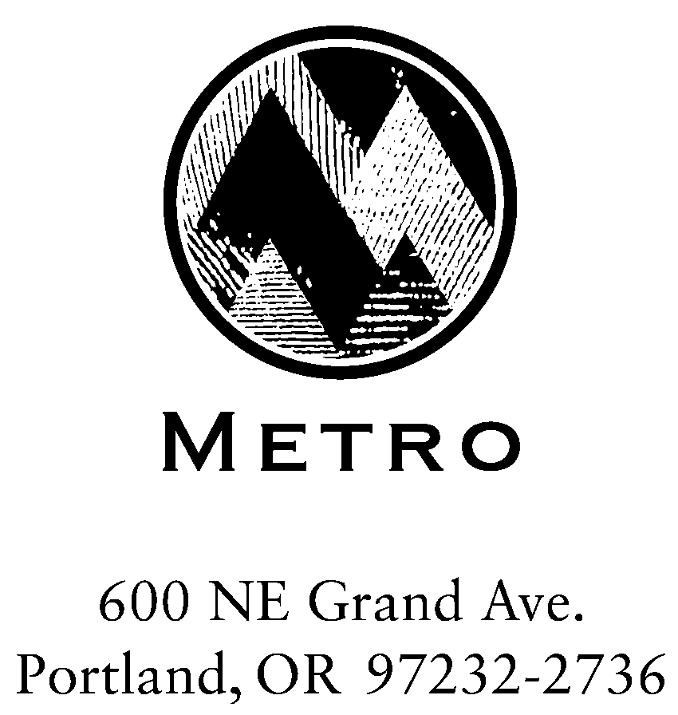

Meeting: Rate Review Committee
Date: March 29, 2005
Day: Tuesday
Time: 6:00 – 8:00 p.m.
Place: Metro Regional Center, Room 370A

Agenda

- Call to Order (5 min) Rod Park
Distribution of minutes for the March 15 and March 22 meetings.
- The FY 2005-06 Requested Budget and FY 2005-06 Rates (45 min.) Doug Anderson
Distribution of a summary of the FY 2005-06 requested budget, together with solid waste rate options and analysis based on the three allocation models* presented at last week’s meeting. Introduction to other issues and considerations for FY 2005-06 rates. (Materials distributed at the meeting).
* The public goods model, cost-of-service model, and the phased cost-of-service model (status quo).
Outcome: understanding of the technical foundation for FY 2005-06 rates.
- Discussion (65 min) Rod Park
Discussion of the alternative rate models and comparison of their effects on ratepayers and private facility operators. Identification of any additional technical, informational and modeling needs.
Outcome: understanding of FY 2005-06 rate options and their impact on the system.
- Wrap Up (5 min) Rod Park

Please contact Tom Chaimov at Metro with any questions at chaimovt@metro.dst.or.us or 503-797-1681.

Committee Members |  |  |  | Metro Staff
Matt Korot, City of Gresham | Paul Matthews, Integrated Utilities Group |  | Michael Hoglund, SWR Director
Mike Leichner, Pride Disposal | Mike Miller, Gresham Sanitary |  | Douglas Anderson, SWR Manager
Ray Phelps, Allied | Michelle Poyourow, Public Power Council |  | Tom Chaimov, Senior SW Planner
Councilor Rod Park, Chair |  |  | Karen Feher, Finance & Admin.

DA:gbc
/tmp/in/input.doc
Queue

