Metro Records & Information Management Copyright Statement

As a government organization, Metro is committed to promoting accountability and transparency in government, and to preserving its history for the benefit of decision-makers and the public by making digital records available online. This includes Metro Online Records, Metro's digital archives and special collections, finding aids, oral history transcripts, photographs, publications and more.

Metro’s Digital Records Repository
Metro’s records include content created by Metro; reference materials used to inform decisions; content that is received from other agencies; and submissions by the public while conducting business with Metro.

By submitting content to Metro, members of the public and partnering organizations do so with the understanding that they are granting Metro a non-exclusive, perpetual, worldwide, irrevocable license to use such material. These records are considered Metro records; as such, they are subject to Metro’s records retention schedule, Oregon public records law, and Metro records management policies and procedures.

Metro reserves the right to include these records in permanent archival collections and make them available to the public. Metro makes no claims regarding the authenticity or accuracy of materials or comments submitted by the public or organizations doing business with Metro.

Terms and Conditions
As a government organization, Metro provides public access to its many of its digital records for research and in support of public transparency. Some of the materials contained in Metro’s archival collections may be protected by domestic and/or international copyright and property laws.

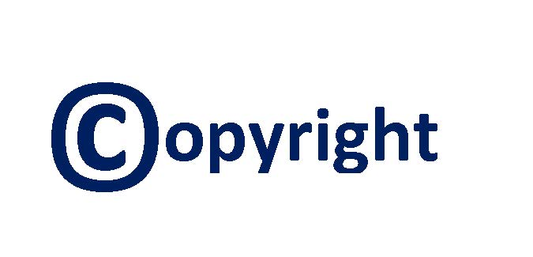

The records in Metro’s collections have been posted online when either permissions are received, the work is determined to be in the public domain, or can be used under fair use as part of a non-commercial, educational site. These rights do not extend to users accessing this site. Users will need to determine for themselves if an item is protected by copyright or in the public domain, and then satisfy any copyright or use restrictions when publishing or distributing materials from Metro’s collections.

Transmission or reproduction of protected items beyond what is allowed by fair use or other exemptions requires written permission from the copyright holder. Users are responsible for obtaining their own necessary permissions. Metro does not provide advice to patrons about which materials are protected by third party rights and which materials may be used freely. If members of the public have questions about the legal issues surrounding the use of these records, they should seek legal advice from a qualified attorney.

Takedown Statement
The authors of any materials included in Metro’s digital collections can request limited public access to the materials. However, Metro recommends this option be carefully considered, as its public repository is intended to provide long term public access to, and aid in the preservation of records.

Questions about Metro’s copyright statement?

Contact us at:
records@oregonmetro.gov

Want to learn more?

Learn about Metro’s records management at: oregonmetro.gov/records
To preserve the integrity of Metro’s permanent record collections, materials will only be withdrawn under limited circumstances. If the decision is made to withdraw certain materials from Metro’s website, it is with the understanding that Metro will continue to preserve them. Authors may request their works be withdrawn by contacting Metro at records@oregonmetro.gov.

The following reasons may contribute to a request to withdraw materials from Metro’s Archives and Special Collections or Metro Online Records webpages:
- The item contains information that is sensitive, restricted, or otherwise should not be public
- The item is in violation of copyright or other laws
- The item has been proven to be fraudulent or plagiarized
- Continued online access to the item poses a legitimate and proximate threat to the safety or wellbeing of an individual

Reasons that do not by themselves justify withdrawal:

- Author is embarrassed by something they wrote
- Someone is offended by the item
- The item is outdated or superseded by a new version

Any requests to withdraw materials from Metro’s Archives and Special Collections or Metro Online Records webpages will be reviewed by appropriate Metro staff. The requester can expect to receive a response from Metro within five business days. In some cases, materials may be temporarily withdrawn from public view while the request is under review.

