MEETING SUMMARY
Rate Review Committee
Metro Regional Center – Room 270
March 8, 2005

Present:
Members Metro Guests
Ray Phelps Doug Anderson, Solid Waste & Recycling Dean Kampfer, Waste Mgmt
Mike Leichner Tom Chaimov, Solid Waste & Recycling
Michelle Poyourow Karen Feher, Finance & Admin. Services
Matt Korot Gina Cubbon, Administrative Secretary, SW&R

Members Absent:
Councilor Rod Park, Chair
Paul Matthews
Mike Miller

Doug Anderson began the meeting by noting that Councilor Rod Park, who will be chairing the Rate Review Committee this year, was in Washington, DC, and therefore unable to attend. The Councilor does, Mr. Anderson said, intend to be at subsequent RRC meetings. Since this meeting was called specifically as a new member orientation, Mr. Anderson asked those present to introduce themselves and give some background on what they do, and their interest in the Committee.

Ray Phelps, from Willamette Resources, Inc. said that he has “...interest in all things Metro.” Mr. Anderson asked if he had an interest in the solid waste system and the outcome of this group; Mr. Phelps answered frankly, “Yes, more than a passing interest.” In answer to another question by Mr. Anderson, “Will that become more apparent as we deliberate this season?” Mr. Phelps said, “If I do my job well, no.” The group laughed appreciatively.

Pride Disposal’s Mike Leichner, beginning his second term on the Committee, explained that he also operates Pride Recycling Company, a local transfer station in Sherwood. “Like Ray [Phelps],” Mr. Leichner said, “I’m interested in seeing what’s going on... It was a good year last year [in the Committee]; tough, but we made a lot of progress last year.”

Matt Korot is with the City of Gresham’s Recycling & Solid Waste Program: “I really consider myself here not as a Gresham representative, but as a representative of local governments that are involved in rate-setting and solid waste collection.” Mr. Korot and Mr. Anderson commented that this is the first year local governments have been part of the RRC.

This year’s citizen rate-payer representative is Michelle Poyourow. “I’m from the Public Power Council,” she informed the group. “I work mostly on a little bit of forensic accounting on the finances of the Bonneville Power Administration, and also analysis of how they set their power rates.” She said that she’s fairly new in her analysis position, and “Just as much as that might help me understand what we’re going to do here, what we do here may help me understand what I do at my job better.... and I love utilities.”

Mr. Anderson gave a brief bio of his time with Metro’s Solid Waste Department, stating his principal role has become “institutional fossil.”

Tom Chaimov works in Mr. Anderson’s division, “I’m a planner with dollar signs attached – I do a lot of number-related things but also work on fiscal impacts of policy decisions.” Mr. Chaimov has helped staffed the RRC for five years, he said.

Mr. Anderson mentioned that RRC meetings are always open to the public. To complete introductions, therefore, from the audience, former RRC member Dean Kampfer (Waste Management), and Metro’s Karen Feher (Finance and Administrative Services) introduced themselves.

Mr. Anderson gave a preview of the night’s agenda, adding that any issues that the members may want to bring to this rate-setting season would be noted for future agendas. He and Mr. Chaimov then explained each of the following attachments, answering member’s questions as they came.

- Topic Outline
- Rate Review Committee contact information (staff contact information has been added since the meeting)
- Charge of the Solid Waste Rate Review Committee (from Metro Code)
- Solid Waste System “sketch” and explanation
- FY 2005-06 SW&R Functional Organization chart
- FY 2004-05 SW&R Program Budget (FY 2005-06 budget numbers have not yet been released)
- Legal Constraints on Metro’s Solid Waste Rates
- How Metro sets its tip fee
- Rate setting criteria

Mr. Anderson presented an historical perspective of Metro’s role in the region’s solid waste system with frequent interjections by Mr. Phelps, who has been both a part of Metro in years past, and an active member of the solid waste industry. When one member queried why solid waste from Metro’s transfer stations is taken to a site over 150 miles away in Arlington, Oregon, which placed the landfill on agricultural lands, Mr. Phelps noted frankly, “Cows don’t beef.”

During the course of the orientation, Ms. Poyourow asked for copies of regional maps showing the different types of facilities (which Mr. Chaimov used as visual aids during his presentation). She asked that franchises be included.

Issues to be included in future discussions:

- Different costs of service across private facilities, Metro rate, price leader, private facility economics – relationship
- Who pays stranded investments?
- “Tax” credits for recovery.

After general and sometimes lively discussion, the meeting adjourned at 8:10 pm.

Next meeting: Tuesday, March 15, 2005
6:00 p.m. Room 370A

gbc
/tmp/in/input.doc
Queue
Rate Review Committee New Member Orientation
Topic Outline
March 8, 2005

Part I: General Overview

- Committee Overview
(Handouts: Charge of the RRC, Committee Membership List)
  - Charge of the RRC
  - Roles on the RRC
  - Introductions
  - Scheduling

- The Solid Waste Marketplace
(Handout: The Solid Waste System – sketch and explanation)
  - Brief History
  - Current System Functions: Public/Private provision of services

- Metro’s roles
(Handout: Functional Organization Chart)
  - Functions
  - Customers & Services

---------------- BREAK ----------------

Part II: Finance & Rates

- Overview of Finances & Rate
(Handouts: How Metro Sets its Tip Fee – three slides)
  - Uses
  - Sources
  - Current rate

- Rate Setting
(Handout: Legal Constraints on Metro’s Solid Waste Rates)
  - Authority
  - Charter & ORS restrictions
  - Rate setting process & criteria

- Q & A, and Next Steps
Rate Review Committee
Updated March 8 2005

Members | Representing | Phone | Fax and e-mail
Rod Park, Chair | Metro Council | 503-797-1547 | 503-797-1793  parkr@metro.dst.or.us
Mike Miller | Business-related Financial Experience | 503-665-2424 | 503-666-0917  mike@greshamsanitary.com
Mike Leichner | Solid Waste Haulers | 503-625-6177 | 503-625-6179  mike@pridedisposal.com
Ray Phelps | Solid Waste Haulers | 503-570-0626 | 503-570-0523  ray.phelps@awin.com
Matt Korot | Person Involved in a Local Recycling or Waste Reduction Program | 503-618-2624 | 503-661-5927  matt.korot@ci.gresham.or.us
Michelle Poyourow | Citizen Ratepayer | 503 232-2427 | michellep@ppcpdx.org
Paul Matthews | Experience in Establishing Rates | 503 525-0548 (105) | 503 525-0385  pmatthews@iug.com
STAFF:
Doug Anderson | Manager, SW&R Financial Management & Analysis Division | 503-797-1788 | 503-797-1795  andersond@metro.dst.or.us
Tom Chaimov | Senior Solid Waste Planner, FM&A Division | 503-797-1681 | 503-797-1795  chaimovt@metro.dst.or.us

/tmp/in/input.doc
Queue

Charge of the Solid Waste Rate Review Committee
Excerpt from Metro Code

The RRC is established for the following purposes [Metro Code section 2.19.170]:
(1) To enhance the credibility of solid waste disposal rates and the rate setting process.
(2) To provide a rational, consistent, stable and predictable process for establishing solid waste disposal rates.
(3) To make recommendations to the Metro Council regarding proposed solid waste disposal rates.
(4) The RRC has the authority and responsibility to review and make recommendations to the Metro Council regarding:
(A) Proposed solid waste disposal rates and charges at facilities owned, operated or under contract to Metro (see Metro Code chapter 5.02) and at Metro franchised facilities as provided under the terms of a franchise agreement (see Metro Code chapter 5.01);
(B) All policy and technical issues related to solid waste disposal rate setting;
(C) Direct and indirect expenses included in proposed solid waste disposal rates before the committee; and
(D) Any technical analysis of proposed rates or rate setting procedures, developed by Metro staff or a consultant to Metro, for facilities under the purview of the committee.

/tmp/in/input.doc

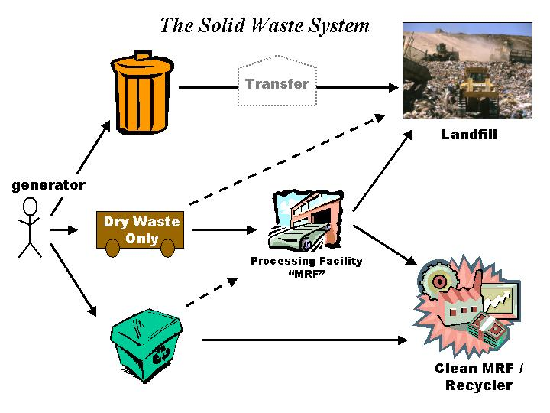

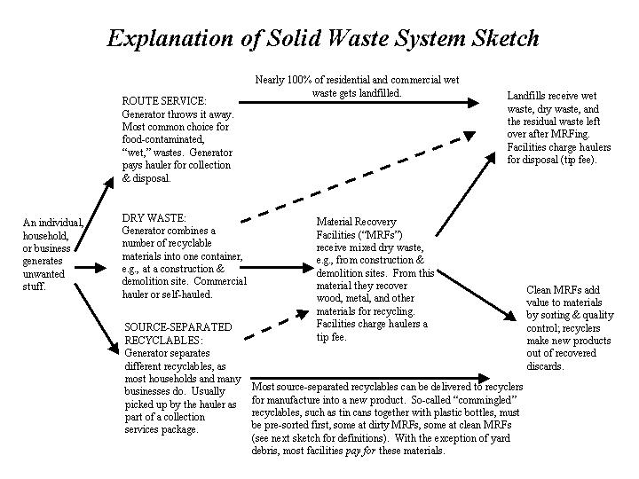

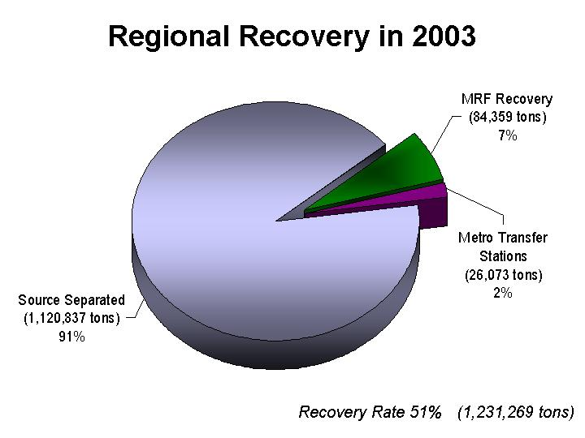

‘/tmp/in/input.doc
FY 2005-06 Solid Waste & Recycling Department Functional Organization* (106.2 FTE)

Department Mission | Reduce the amount and toxicity of solid waste disposed… |  | …and ensure an environmentally sound disposal system for the remainder.

Primary programs  (78.2 FTE) | Waste  Reduction  (20 FTE) |  |  | Hazardous  Waste  (29.05 FTE) |  |  | Private Facility Regulation  (5 FTE) |  |  | Disposal  Operations  (17.65 FTE) |  |  | Landfill  Stewardship  (6.5 FTE)
Activities | Waste  Reduction | Education & Outreach |  | Hazardous Waste | Latex Paint |  | Facility Regulation | Illegal Dumpsites |  | Transaction | Tonnage |  | Plans & Management | Site operations
 | 7.67 FTE | 12.33 FTE |  | 25.3 FTE | 3.75 FTE |  | 3.5 FTE | 1.5 FTE |  | 15.15 FTE | 2.5 FTE |  | 1.5 FTE | 5 FTE
Goals | Provide the opportunity to recycle. | Knowledge, proper use of opportunity. |  | HHs & CEG: test, recycle, dispose. | Paint management: reblend, sale. |  | Implement & enforce Metro Code. | Respond to illegal disposal. |  | Oversight & management of Metro transfer stations and major disposal contracts. |  |  | Post-closure management of landfills per DEQ permits; methane gas recovery & sale.
——————— | ——————— | ——————— |  | ——————— | ——————— |  | ——————— | ——————— |  | —————————————— |  |  | ——————————————
Elements | - Base prog-ram grants  - New initiatives  - Planning & technical | - RIC  - School education  - Haz.waste & adult education |  | - Permanent facilities  - Round-Ups | - Receive, test, color sort, process  - Storefront |  | - Licensing, franchising  - Inspections  - Enforcement | - Monitoring  - Cleanup  - Investigation |  | - Management (3 FTE)  - Scalehouse (12.65 FTE)  - Transfer/disposal; major contracts (2 FTE) |  |  | Post-closure management, environmental monitoring. | Site  operations, measurement and maintenance.

Direct support programs |  | Safety & Emergency Response (1 FTE) |  | Engineering, Design, Construction (4 FTE)
(5 FTE) |  | - Staff safety & ergonomics  - Regional Disaster Debris Management plan/response  - FEMA reimbursement eligibility |  | - Renewal/Replacement & Capital Improvement plans  - Engineering & design: facilities, landfills  - Construction procurement & management.

General administration, support & business |  | Office of the Director |  | Support  Services |  | Community & Media Relations |  | Business, Finance, Budgeting |  | Interfund  Transfers |  | Debt  Service
(23 FTE) |  | 3 FTE |  | 7.5 FTE |  | 2.5 FTE |  | 10 FTE |  | $4.0 million |  | $2.3 million
 |  | Director & staff |  | - Secretarial  - Reception  - Records, library  - Data entry  - LEDS access  - FOIA requests  - Graphics/web support  - Supplies |  | - Enhancement grants  - Neighborhood grants  - Disposal Vouchers  - Advertising  - Media/press  - Web content |  | - Budgeting & rates  - Accounts payable, payroll, RSF credits  - Procurement, contract administration  - Performance measures  - Data bases, forecasts  - Audits & procedures |  | - Metro administration  - Building services  - Legal, IT  - Human Resources  - Accounting  - Creative services  - Insurance, risk  - Planning fund
* Functions and figures are taken from the requested (i.e., not yet adopted) budget, and may be subject to change.
Solid Waste and Recycling Department FY 2004-05 Program Budget
Discussion Draft – November 8, 2004

Solid Waste and Recycling Department FY 2004-05 Program Budget
Discussion Draft – November 8, 2004
Legal Constraints on Metro’s Solid Waste Rates

Oregon Revised Statutes
459.335: Use of Fees Collected by the Metropolitan Service District.
…the metropolitan service district shall use moneys collected by the district as service or user fees for solid waste disposal for activities of the metropolitan service district related to solid waste and related planning, administrative and overhead costs of the district.

Metro Charter
Section 15: Limitations on Amount of User Charges
…charges for the provision of good or services by Metro may not exceed the costs of providing the goods or services. These costs include, but are not limited to, costs of personal services, materials, capital outlay, debt service, operating expenses, overhead expenses, and capital and operational reserves attributable to the good or service.

Metropolitan Service District Master Bond Ordinance (Ordinance 89-319)
Section 702 (j): Rate Covenant
At all times, the Issuer [Metro] shall establish, levy, impose, maintain and collect fees, rates and charges for the use of the service and facilities of the System as shall be required to provide Net Revenues in each Fiscal Year which at least equal to 110% of Annual Debt Service on all Outstanding System Bonds and Issuer Financial Obligations for such Fiscal Year….

/tmp/in/input.doc

Rate Setting Criteria

Adapted from Resolution #93-1824A

- Consistency: Solid waste rate setting should be consistent with Metro’s agency-wide planning policies and objectives, including but not limited to the Solid Waste Management Plan.

- Revenue Adequacy and Reliability: Rates should be sufficient to generate revenues that fund the costs of the solid waste system.

- Equity: Charges to users of the waste management system should be directly related to services received. Charges to residents of the Metro service district who may not be direct users of the disposal system should be related to other benefits received.

- Waste Reduction: The rate structure should encourage waste reduction, reuse, and recycling.

- Affordability: Rate setting should consider the customers’ ability to pay, e.g., the cost of living for residential customers and the cost of doing business for commercial customers.

- Implementation and Administration: Rate setting should balance the relative cost and effort of implementing and administering the rates with financial and policy goals. Rates should be enforceable.

- Credit Rating Impacts: The rate structure should not negatively impact Metro’s credit rating.

- Authority to Implement: Metro should ensure that it has the legal ability to implement the rate structure; or, if such authority is not already held, evaluate the relative difficulty of obtaining the authority.

- Predictability: Metro rate adjustments should be predictable and orderly to allow local governments, haulers, and rate payers to perform effective planning.

/tmp/in/input.doc

