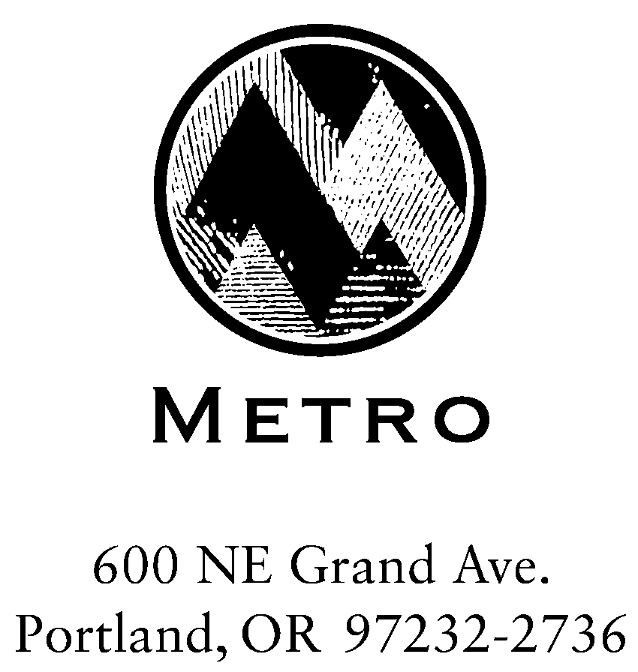

MEETING SUMMARY

SWAC Subcommittee - RSWMP Sustainability Group

Metro Regional Center, Room 370B
March 28, 2005

Members Present:

René Eyerly, Metro Solid Waste & Recycling Department, Office of the Director
Steve Apotheker, Metro, SW&R, Waste Reduction & Outreach Division
Babe O’Sullivan, City of Portland
Lori Stole, Washington County Citizen
Jeff Murray, Far West Fibers
Mike Miller, Gresham Sanitary
Dave White, Oregon Refuse Recycling Association
Heather Hansen, Clackamas County Citizen
Tom Badrick, Legacy Health Systems
Wade Lange, Ashforth Pacific

Members Absent:
Eric Merrill, Waste Connections

Guests and Metro staff:
Larry Chalfan, Zero Waste Alliance
Marsha Willard, AXIS Performance Advisors
Dean Kampfer, Waste Management of Oregon
Gina Cubbon, Administrative Secretary

René Eyerly opened the meeting, saying she’s very excited to have the issue of sustainability included in the RSWMP update. “I really appreciate everyone volunteering for this ambitious and quick-paced project,” she said. After having everyone introduce themselves, Ms. Eyerly went over the group’s scope of work (attached), and previewed upcoming meetings. This meeting would focus on background information needed move forward. Marsha Willard and Steve Apotheker, Ms. Eyerly continued, would make presentations, “...to try to get everybody familiar with the terminology, some of the theory, and frameworks that we’re going to be deciding on before we move forward with our goals.”

On a housekeeping note, Ms. Eyerly introduced the concept of the “Issue Bin.” “I like to use it because it’s a good place to record topics that might be interesting but tangential to the discussion, or topics/ideas that are controversial but maybe not ‘of the moment. It’s a way to stay focused on the agenda topics at-hand.”

An “Action Item” list will be included in each of the meeting summaries, Ms. Eyerly continued, to keep a record of assignments, research, etc. and when they’re due. Thirdly, she presented a list of “Ground Rules,” and said more can be added as the group feels appropriate. (“Ground rule #1 – no side conversations!” meeting clerk Gina Cubbon quipped.)

Ground Rules:
- Everyone participates; no one dominates.
- Keep an open mind; listen to alternative views.
- As much as possible, decisions will be based on data.
- Start on time, end on time.
- Help the group stay on track if it wanders off the agenda.

The group agreed these ground rules seem appropriate.

Ms. Eyerly turned the meeting over to Steve Apotheker, who gave some brief background as to the purpose of the SWAC subcommittee, which came into being after feedback from public outreach and surveys indicated strong interest in sustainability. Local governments throughout the Region are incorporating sustainability more into their everyday practices. “The City of Portland Office of Sustainable Development with their Green Building Program, Gresham with its Resource Efficiency Program, and DEQ adopting programs that give wastesheds two percent credits for adopting green building programs, conducting resource efficiency programs, promotion programs that relate to materials that are energy intensive or especially toxic,” Mr. Apotheker said. This committee, he continued, will look at sustainability and how the Region might apply the concepts involved. The first step would be to decide upon what type of framework the group believes might best suit this project.

Mr. Apotheker introduced Marsha Willard of AXIS Performance Advisors, a consulting group that has worked with Metro on previous projects, primarily with the in-house sustainability team. Recently, AXIS took a look at Metro Transfer Stations; as a result of their recommendations, “...we built into our transfer station contract a number of sustainability requirements, including janitorial products, recycled paper, and Metro Council allocated additional funds to make sure we could buy green energy as a percentage of our total energy use, and deal more affectively with air quality issues.”

Taking the floor, Ms. Willard presented information about frameworks the group may choose to use for the project, including examples other companies have used. She explained that AXIS’ role is to help show companies how they can integrate sustainability practices rather than giving technical expertise. They build the frameworks from which to grow; a good framework provides an end-point.

Copies of the PowerPoint slides Ms. Willard used in her presentation are available upon request (file too large to e-mail). They show the purpose of frameworks, and detail specific types:

- Triple Bottom Line employs a complex interdependency between the environment, the economy, and social equity. Its premise is that it is unacceptable to sacrifice any one for another. This framework defines a high principal, but not a goal. There is no specific process or direction involved. (Example included: OMSI)
This framework has been helpful to organizations that didn’t initially understand their role in a sustainable society. For instance, a manufacturer may not realize how the markets from which they buy materials are affected environmentally by those materials, nor labor issues involved in other countries.

- The Natural Step uses “system conditions” or scientifically-derived rules for an environmentally sustainable society. This framework sets specific conditions, but not how to get there.
Examples Ms. Willard noted anecdotally included a fabric company that developed a way to change a process that had included use of 1,600 chemicals to using just eight chemicals. New York City found that they could save money by restoring a watershed (at a cost of $300 million dollars) rather than building an $8 billion dollar treatment facility. The Oregon Department of Corrections found an extra use for buses: After they transport prisoners to their facilities around the state, they load the buses with excess produce from local farmers and donate it to the Oregon Food Bank.
Ms. Willard divided the attendees into groups to do an exercise using the principals involved above. One group was to act as a health insurer; one as an electronics manufacturer, one as a building company. Ideas the groups came up with included offering incentives for reduced health insurance rates to companies incorporating sustainable practices; manufacturers instituting take-back programs, and locating factories nearer their needed resources; builders using certified renewable materials and concentrating more on remodeling than demolition and new construction.

- The Environmental/Sustainability Management System begins with programs many companies have already instituted (EMS – Environmental Management System), and converting it into a Sustainable Management System. This framework is strong on process, but is merely a monitoring tool and supplies no standards.
Locally, Hot Lips Pizza has successfully used this model, Ms. Willard said, noting that “It’s not about finding perfect answers; it’s about helping you make decisions.” Jeff Murray used Burgerville as an example – they use local products, which helps the economy as well as cutting down on transportation, which helps air quality, etc.

- Mission frameworks use an organization’s mission statement to create a set of measurement tools to support it.

There are a myriad of framework choices, Ms. Willard concluded her presentation. She encouraged the group to research the examples above or search out others on the Internet. Many companies marry more than one type; the variations are endless and available to suit each situation.

The group embarked on general discussion and next steps. Remarks included wanting to refine where the region’s resources will end up, and to not look at small goals because major goals “get things moving.” There was concern voiced that if specific numbers are set as goals, they could distract from the mission. Perhaps keep the goal so broad (such as “zero”) that there is less likelihood of getting bogged down in details. On the other hand, a way to quantify progress is important in order to stay motivated. Goals can, and will, continue to change and evolve.

The meeting adjourned at noon.

Action Items for Next Meeting

Action Item | Assigned To | Date Due
None

Next Meeting:
Wednesday, April 13, 2005
Time: 9-11 am
Location: Metro Regional Center, Room 274

gbc
/tmp/in/input.doc
Queue

Sustainability Goals
Scope of Work
March 2005

Metro will facilitate a multi-disciplinary team of solid waste system stakeholders to develop goals that could guide system activities to become more sustainable over the next 10 years. The team members on this project will:
- Define sustainability as it relates to the solid waste system
- Map the components of the solid waste system and determine the leverage points in the system where changes could be made to improve sustainability
- Develop goals to move the system towards sustainability over the next ten years

Process

Meeting 1
  - Establish ground rules and team process.
  - Provide background on, and discuss examples of, sustainability.

Meeting 2
  - Discuss and agree on sustainability framework in which to analyze the solid waste system.
  - Provide and discuss system map of the local solid waste system. The system map would show the different steps or components of the system, along with inputs and outputs (energy, materials, emissions).

Meeting 3
  - Identify the associated impacts (human toxicity, ecotoxicity, biodiversity, greenhouse gas emissions, energy, equity, safety, etc.) of each system component.
  - Determine what components of the system should be evaluated. (System definition)

Meeting 4
  - Discuss the characteristics of the selected system components if it were sustainable according to the framework adopted.

Meeting 5
  - Identify system components and impacts where greatest leverage can be exerted to move the system toward sustainability in the next 10 years.

Meetings 5 and 6
  - Develop goals for the next 10 years.
  - Identify next steps.

Output
Draft sustainability framework, system definition, and goals for SWAC and Council consideration and potential inclusion in the updated RSWMP.

Two Definitions of Sustainability
“Sustainable development is development that meets the needs of the present without compromising the ability of future generations to meet their own needs.” United Nations Commission on Environment and Development

“Sustainability means using, developing, and protecting resources at a rate and in a manner that enables people to meet their current needs and also provides that future generations can meet their own needs.” State of Oregon

