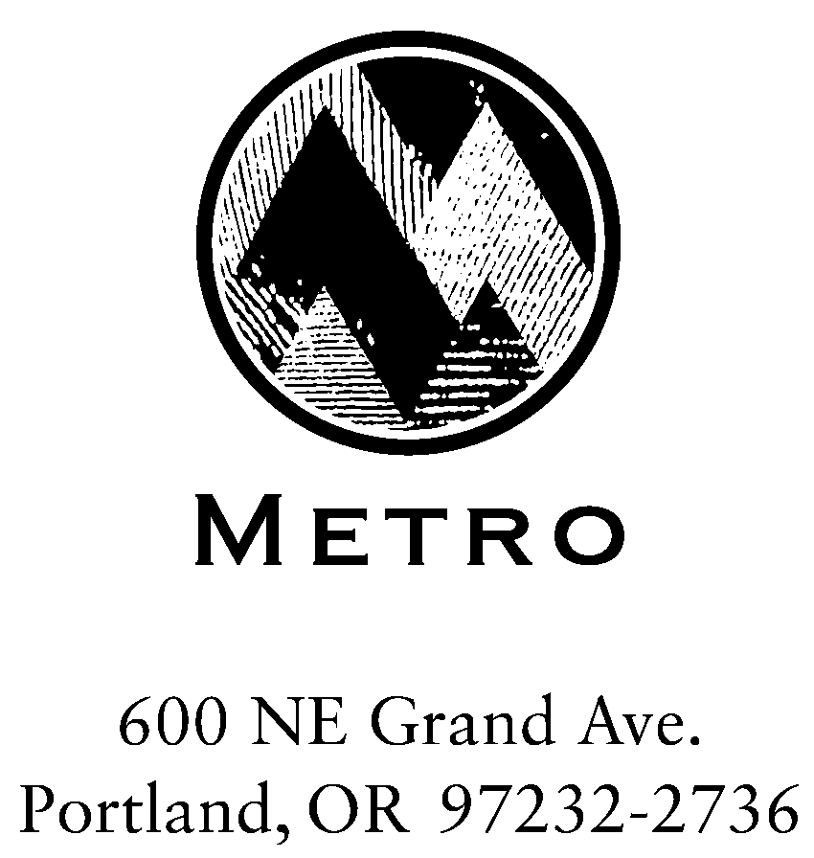

A G E N D A
(Addendum)

Meeting: Metro and Industry
Date: March 7, 2005
Day: Monday
Time: 1:00 PM – 2:30 PM
Place: Room 275, Metro Regional Center, 600 NE Grand Avenue, Portland

Addendum to Agenda:

Review integrated RSWMP/DSP Scope & Timeline Mike Hoglund

Review Upcoming Council Work Session & Direction Mike Hoglund
* April 12th (Wk Session) Disposal system historical background &
current policy foundation
* Council Session (TDB) – Resolution to proceed

Industry Comments or Questions Industry Reps

Other Issues All

