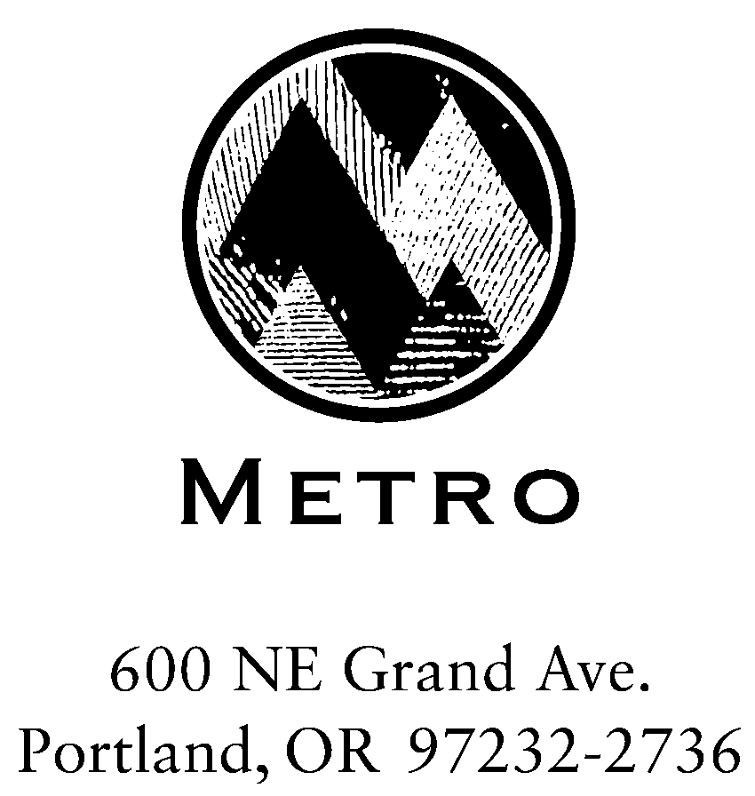

A G E N D A

Meeting: Metro and Industry
Date: March 7, 2005
Day: Monday
Time: 1:00 PM – 2:30 PM
Place: Room 275, Metro Regional Center, 600 NE Grand Avenue, Portland

Meeting Objectives:
- To review key Metro Council decision points (and anticipated projects) along an integrated Regional Solid Waste Management Plan and Disposal System Planning timeline.
- To identify the opportunities in the process for solid waste and recycling industry input and feedback.
If objectives of a and b, above, are met:
- For Metro staff and industry reps to agree to let the process run its course, subject to Council revision to the schedule.

Agenda:

March 1st Council Direction for RSWMP/DSP Process Mike Hoglund

RSWMP/DSP Integrated work plan Mike Hoglund

Industry Objectives for RSWMP/DSP Industry Reps

Next Steps Ray Phelps & Mike Huycke

